**Safe House Rules (Version 2.0)**

**Designed by Anthony J. Elam, @2012, 2016**

**Installation –** Once all the source and execution files are downloaded to your local machine, copy the path to index.html and paste it into a browser. This will give you the starting screen for Safe House.

**Summary –** Safe House is a game of investigation, teamwork and survival for 3-9 players.

Players take on the role of terrorists, counter-terrorist and neutral characters. Each character has different winning conditions and initially no one knows each other’s identity. During the game you must uncover your teammates and enemies. Killing your enemies is always a top priority, as is survival!

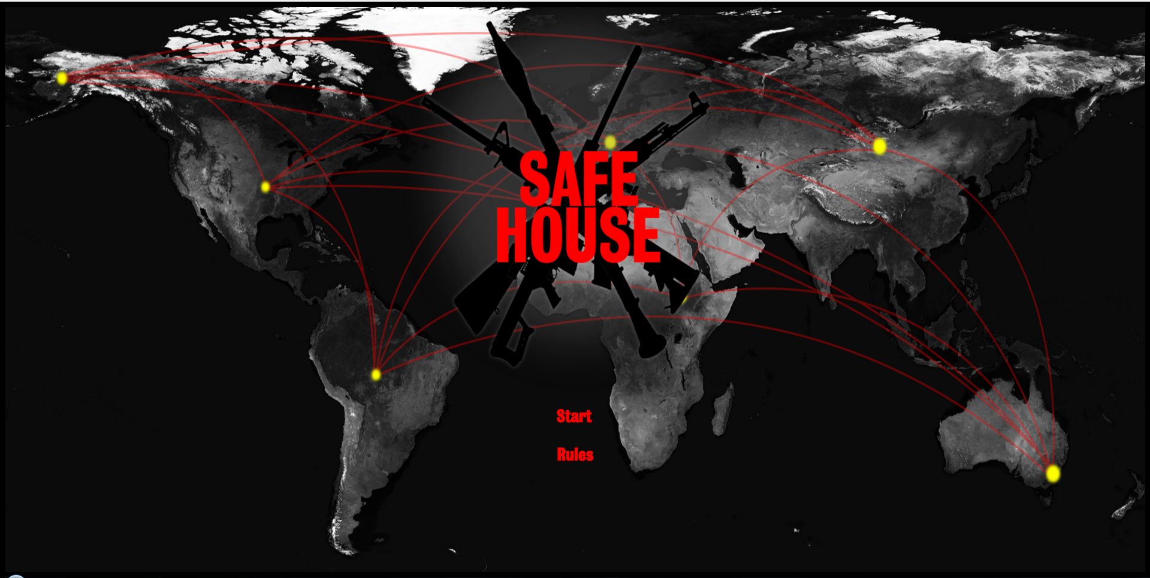

**Components** – 1 Game Board, 1 Damage Track Board, 17 Defensive Cards (silver), 17 Offensive Cards (black), 17 Investigative Cards (yellow), 10 Character Cards (purple) – 3 terrorists, 3 counter-terrorists, 4 neutral, 10 Safe House Player Summary sheets, 30 cubes (3 each in 10 colors), 6 6-sided dice (2 green (movement), 2 white (defense), 2 red (attack)).

**Preparation –**

1. Set the play board and the damage track in the center of the table.
2. Shuffle the Defensive Deck (silver backed cards) and place next to the play board.
3. Shuffle the Offensive Deck (black backed cards) and place next to the play board.
4. Shuffle the Investigative Deck (yellow backed cards) and place next to the play board.
5. Each player picks a color and takes the appropriate pieces and player color mini-sheet.
6. Depending upon the number of players randomize the pool of characters (purple backed cards) as follows:

3 players, 1 Terrorist, 1 Counter-terrorist, 1 Neutral

4 players, 2 Terrorist, 2 Counter-terrorist

5 players, 2 Terrorist, 2 Counter-terrorist, 1 Neutral

6 players, 2 Terrorist, 2 Counter-terrorist, 2 Neutral

7 players (A), 2 Terrorist, 2 Counter-terrorist, 2 Neutral, (and one random additional

either Terrorist, Counter-terrorist or Neutral)

7 players (B), 2 Terrorist, 2 Counter-terrorist, 3 Neutral (not George)

8 players (A), 3 Terrorist, 3 Counter-terrorist, 2 Neutral

8 players (B), 2 Terrorist, 2 Counter-terrorist, 2 Neutral, (and two random additional either Terrorist, Counter-terrorist or Neutral)

9 players, 3 Terrorist, 3 Counter-terrorist, 3 Neutral.

1. Shuffle the chosen character cards and deal one to each player. Players look at their character cards to learn their identity. The players keep their character cards secret from the other players and place the card under their color mini-sheet. They may look at their character card at any time.
2. Each player places one of their color markers on the damage track position 0.
3. Each player rolls two dice, high roll goes first (re-roll high dice ties), play proceeds clockwise.

**Game Play** –

Safe House is a game that is designed to be easy to play and fast. Starting with the first player, each player takes a turn in clockwise order until someone achieves their victory condition.

A turn consist of the following actions:

1. Player makes a **MOVE** (mandatory).

2. If the area’s action is a **CARD DRAW** – it is an Optional draw. If drawn follow the instructions on the card. (Place equipment or take action immediately).

3. **ATTACK** other player(s). (Optional and requires other characters in “range”).

**MOVE –**

Roll two green dice (2D6), add the results and move your marker to that area on the board.

Then take appropriate action:

2, 3 – Take a card of your choice (yellow, silver or black)

4, 5 – Take a yellow card

6 – Take a silver card

7 – Safe House, either remain in the safe house area and “safe” OR move to any area

of your choice

8 – Take a black card

9, 10 – Give two damage to any player or heal one point of damage to any player

(you may choose yourself for either)

11, 12 – You may steal an equipment card from any player (if no one has an equipment card then nothing happens)

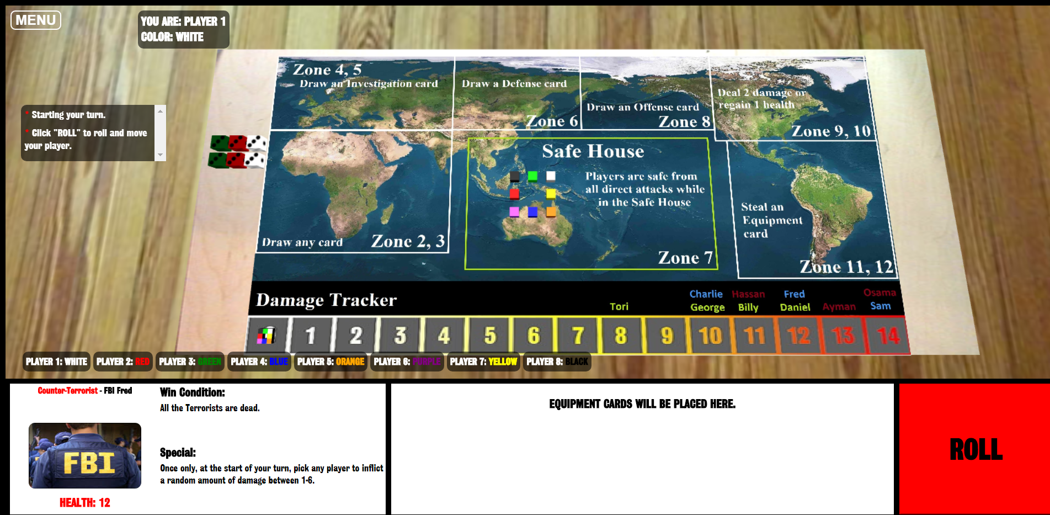

**CARD DRAW** -

**Defensive (Silver) and Offensive (Black) Cards**:

Equipment – place them beside your color mini-sheet. They are now “equipped” and ready to use. There is no limit to the number of equipment cards you can have equipped.

One Time Action – follow the instructions on the card then discard it (face up in a discard pile). When you run out of cards, shuffle discards and make a new stack of cards to draw.

**Investigation (Yellow) Cards**:

Read card, then give the card to any player (do not let others see the card).

The player that then receives the card must take the appropriate action based upon their affiliation – terrorist, counter-terrorist or neutral. If there is no effect, then the player that received the card states “nothing happens”. If there is an effect then take the appropriate action (example: take damage – move your marker on the damage track, etc.). Then return the card to the original player – who can re-read the card before discarding it face down in a discard pile.

If you are given an investigation card, you must not tell a lie and follow the instructions. EXCEPT if you are the terrorist Hassan - who can lie!

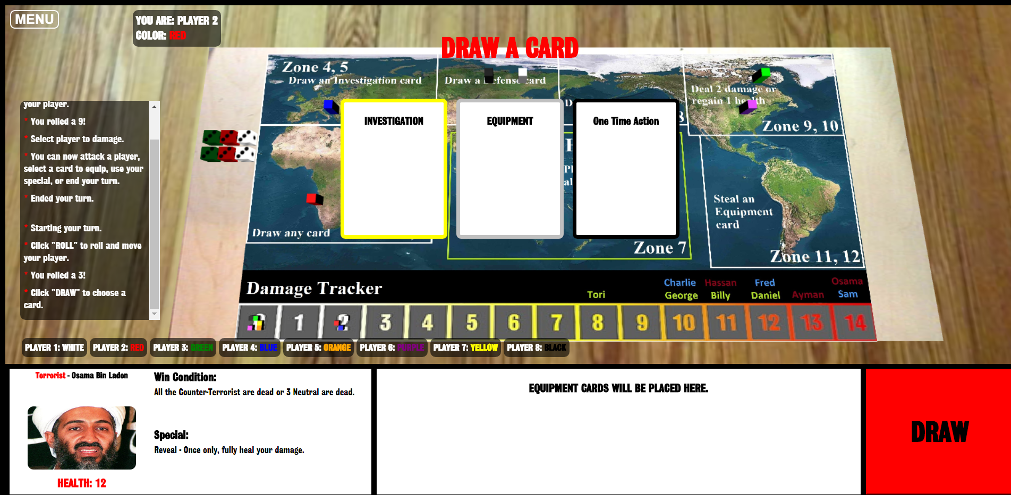

**ATTACK** -

The last phase of a player's turn is their optional attack phase. You may only attack another character/player that is in your same area or if an equipment allows for a ranged attack, you may do so.

If you choose to attack, pick your target and roll 1D6 (red die), the defender (target) rolls 1D6 (white die). If the attacker’s die is greater than the defender’s die then the defender takes the difference between the two die as damage plus any additions or subtractions due to any relevant equipment the attacker or defender may have. If the defender’s die is greater than or equal to the attacker’s die – the defender takes no damage. The attacker may choose to use only ONE black equipment weapon card per attack.

Example A. Attacker rolls a 5, defender rolls a 2 – no equipment involved – defender takes 3 damage!

Example B. Attacker rolls a 6, defender rolls a 4 – attacker has an equipped handgun (1 extra damage) – defender takes 3 damage!

Example C. Attacker rolls a 4, defender rolls a 4 – attacker has an equipped Blow Gun (1 extra damage if attack is successful) – defender takes no damage (attack was not successful).

Note: Equipment effects are not cumulative in attacks with the following exception – if you have the following weapons equipped – Garrote, Blow Gun, Cursed Dagger you may combine their extra damage values to a successful attack. You really want them dead – 1D3+2 damage with NO defense roll due to the Cursed Dagger.

**Player’s Character Death** –

As you take damage move your color marker along the damage track. If your marker lands on the space with your character’s Hit Point (HP) value – you die and are out of the game. Turn your character card face up (if not revealed), remove your marker form the game board.

If you kill another character, you obtain one equipment card of your choice from your victim and discard the rest (unless you have the duffle bag equipped).

**Winning the Game!**

If you fulfill your character’s win condition, you immediately reveal your identity (if not already revealed) and declare that the game is over!

You do not have to wait until your turn to declare the game is over.

All the players who fulfilled their character’s win condition are winners!

Depending upon how the game ends, it is possible for terrorists or counter-terrorist who has been killed earlier to win due to other player’s actions.

**Special Character Abilities -**

You can only utilize your character’s special ability in return for revealing your identity. Exception - Hassan (can lie during investigations).

Some special abilities are one time use, while others stay active (multiple use) when revealed. If you have a one-time use special ability then when used, turn your card 90 degrees to show it has been used (tapped).